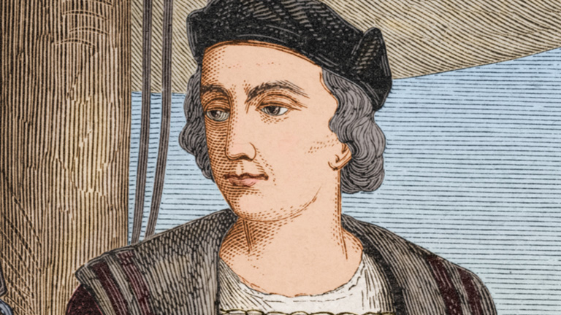

1492: Columbus comes to the Americas on behalf of Spain. He carefully documents the voyages, including directions, currents, and descriptions of the residents as ripe for subjugation. James Loewen’s book Lies My Teacher Told Me speaks to how the race construct begins with this story. He notes how the 12 textbooks most used in the U.S. offer a discovery narrative of an enlightened colonialism that brings the gift of civilization to the “savage.” This narrative ignores the ways in which Columbus truly did transform the modern world through the “taking of land, wealth, and labor from indigenous people in the Western hemisphere, leading to their near extermination, and the transatlantic slave trade, which created a racial underclass.”
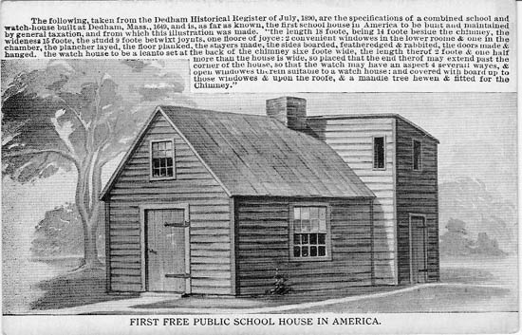

1644: The General Court of the Massachusetts Bay Colony decrees that every town of fifty families should have an elementary school and that every town of 100 families should have a Latin school. The goal is to ensure that Puritan children learn to read the Bible and receive basic information about their Calvinist religion. This is a picture of the first taxpayer-funded public school, built in Dedham, Massachusetts in 1644 to “instruct the youth of the community,” meaning the youth of Puritan townspeople originally from England – not youth of indigenous or African descent.

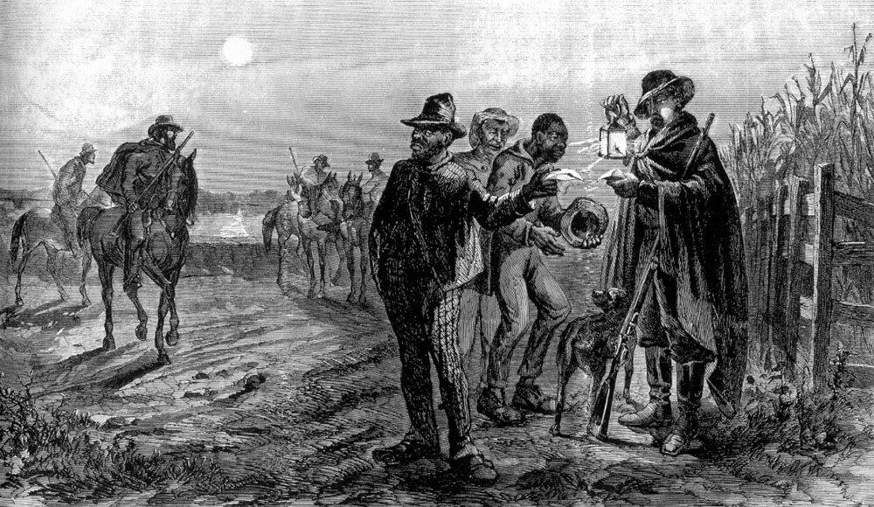

Virginia’s government continues to extend benefits only to white working and poor men. One of the jobs these freed white men can get is on the slave patrols, where they make a living capturing those trying to escape enslavement; poor whites are also hired to oversee black labor, positioning them as “buffers” between slave owners and the enslaved. The landowning elite employ a classic divide and conquer strategy and begin conditioning white working people to identify more with whiteness than with other poor people. These slave patrols are generally considered to be the first "modern" police organizations in this country.

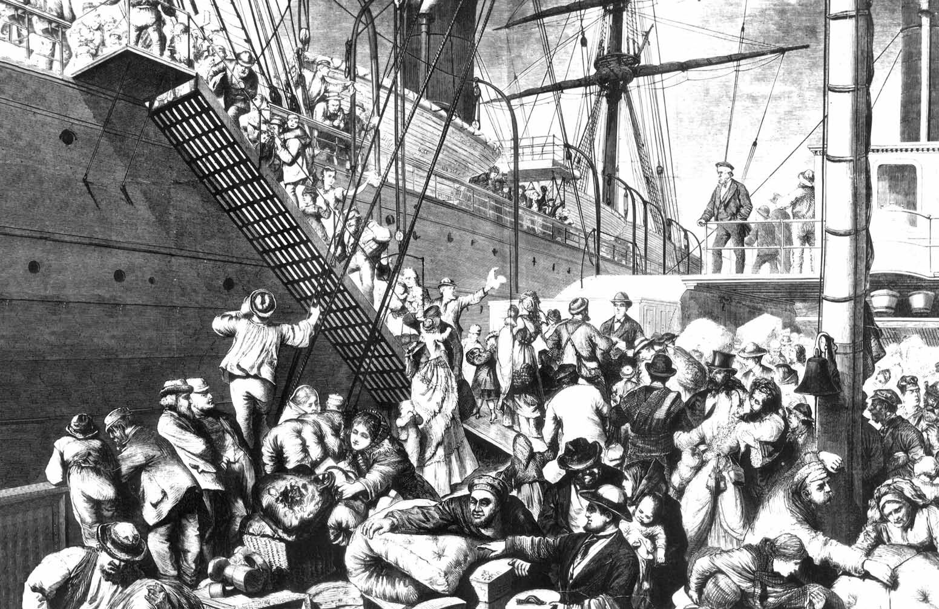

1720: By 1720, German immigrants are coming to the United States in great numbers; English colonists fear that these “foreigners” will influence English culture and language. Laws appear forbidding German printing houses and the import of German books. The Pennsylvania Assembly passes a law requiring all male German immigrants to swear an oath of allegiance to the British Crown. English language schools are recommended for German youth.

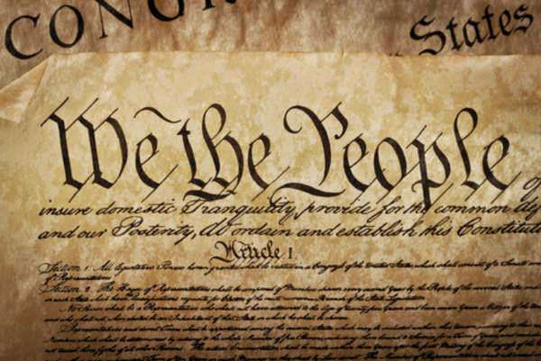

1787: The Constitution is signed, defining African American males as 3/5 of a man and not mentioning indigenous peoples at all. The Constitution leaves the issue of voting rights up to the states and most states limit the vote to those white males who own a certain amount of property, with the result that by the first presidential election in 1789, just 6% of the total population is eligible to vote.

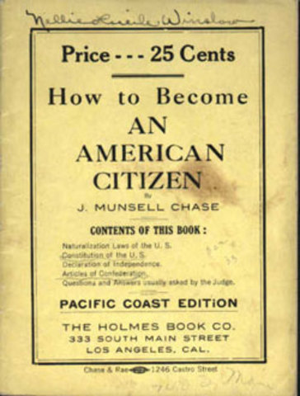

1790: The 1790 Naturalization Act specifies that only free white immigrants are eligible for citizenship. The Act explicitly denies civil rights, the right to vote or own land to first generation immigrants from Asia, the Caribbean, Central and South America and Africa. Indigenous peoples become citizens only through individual treaties or intermarriage. Without citizenship, people of color cannot vote, own property, bring lawsuits, or testify in court all protections and privileges that white citizens take for granted. This Act continues to have influence in various forms until 1952.

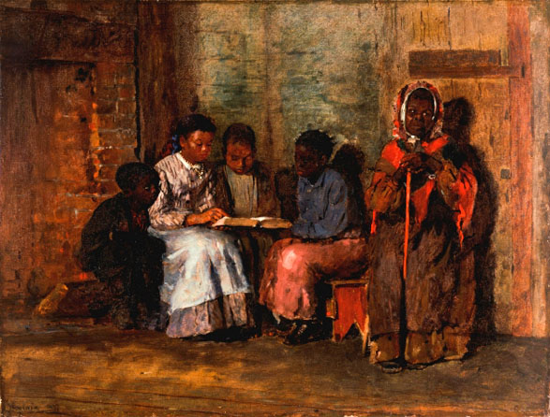

1819: Virginia and other slave states pass acts forbidding the teaching of reading to enslaved people because “teaching of slaves to read and write has a tendency to excite dissatisfaction in their minds and to produce insurrection and rebellion. . .”

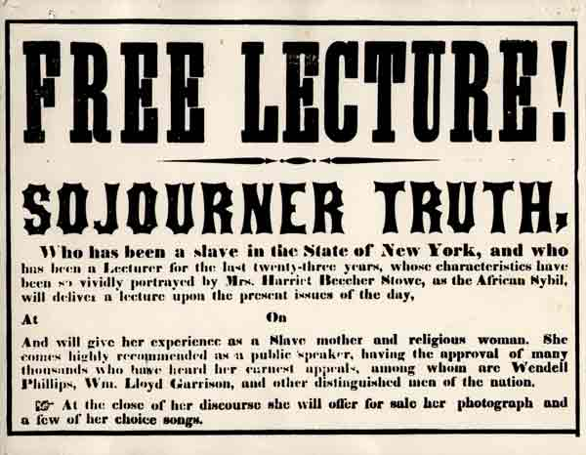

The Abolitionist Movement consisted of a worldwide effort to emancipate slaves, end the slave trade, and restore the human rights of African Americans. It represented protest and outrage against an American economic system that depended on the oppression of an entire race of people in order to benefit a privileged few. Abolitionists spread their message through publications such as The Liberator, founded by influential abolitionist William Lloyd Garrison, who also founded the American Anti-Slavery Society, and powerful writers and speakers such as Frederick Douglass.
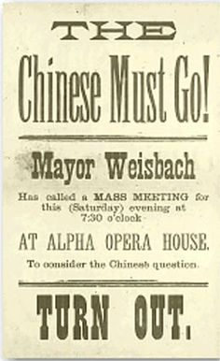

1854: In The People v. Hall case in 1854, the California Supreme Court reverses the conviction of a white man for murder stating that the statements of key Chinese witnesses are inadmissible because “no black or mulatto person, or Indian, shall be allowed to give evidence in favor of, or against a white man.” The Chief Justice notes that if allowed to testify, the Chinese, an “inferior” race, would then be eligible for citizenship, voting, jury duty, which would present a great “danger.”
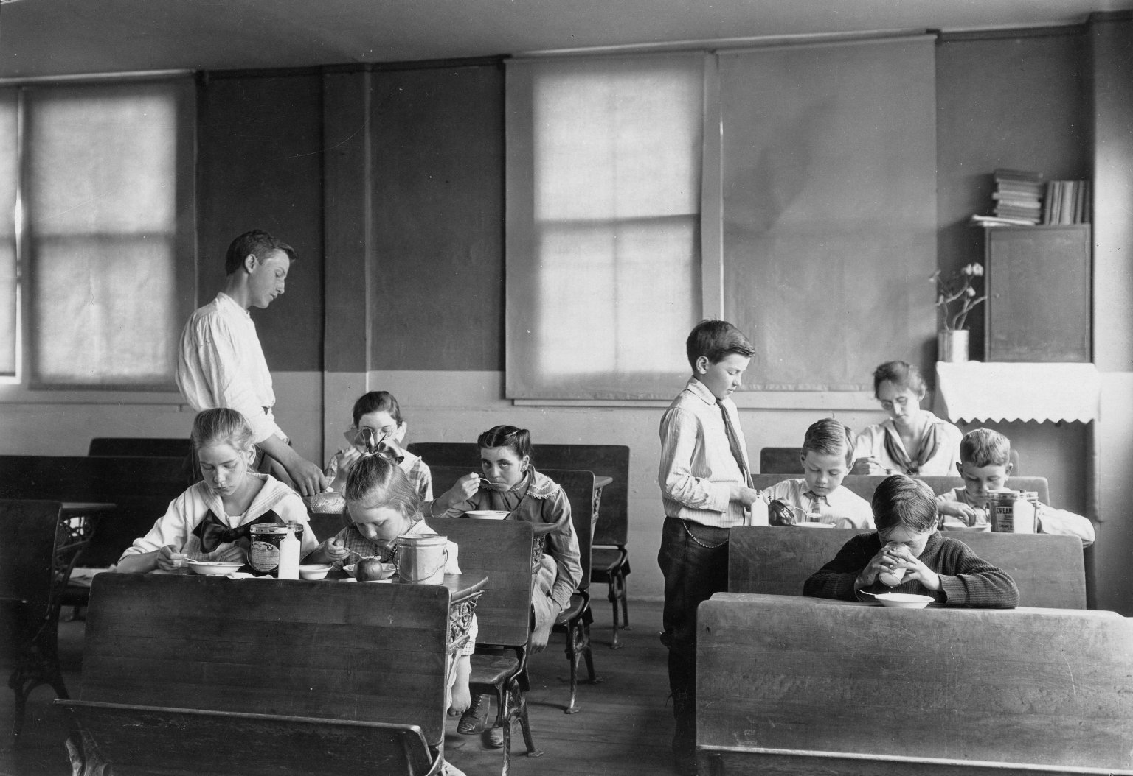

The common school becomes the vehicle through which political and social leaders plan for children to be trained to assimilate into the Protestant Anglo Saxon culture. Common or “free” schools are designed for white children (or immigrants who will assimilate into whiteness). Most schools are segregated and by the late 1840s the Courts begin to pass separate but equal rulings that institutionalize this segregation.

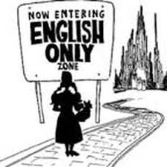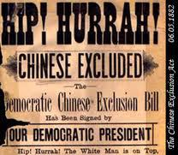

1800s: California requires all school instruction to be conducted in English. The Naturalization Act of 1870 limits naturalization (becoming a citizen) to white persons and persons of African descent, excluding Asian immigrants from naturalization.

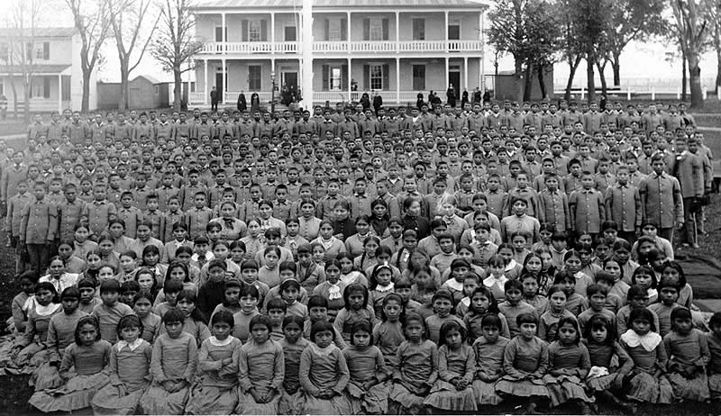

In the late 1870s, Charles Pratt, an army veteran of the Indian wars, opens the Carlisle Industrial Training School in Pennsylvania. His philosophy is to “Kill the Indian, Save the Child” and "elevate" American Indians to white standards. Students must leave their families and upon arrival are given a haircut and an English name. They are forbidden to speak their native language. Punishment is severe and includes the forced washing of mouths with lye soap. Students are taught that their way of life is savage and inferior and that those who wish to retain their culture are stupid, dirty, backward. The schools initiate a pattern of abuse, including sexual and physical abuse continuing throughout the school’s history into the 1930s.

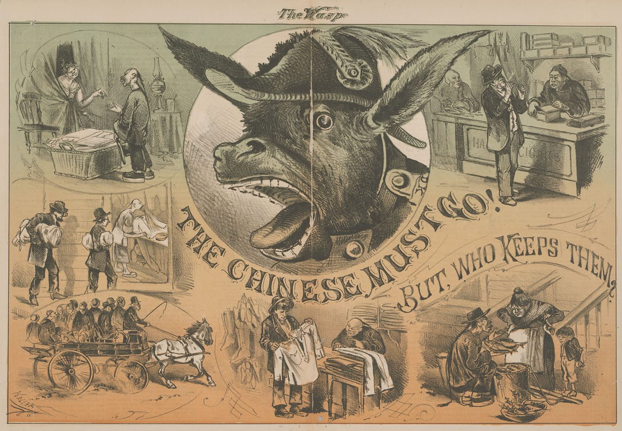

1882: In 1882, the Chinese Exclusion Act is passed, barring most Chinese immigrants from entering the U.S. at all. This is the first time a nationality is barred expressly by name. The majority of organized labor unions continue to oppose the immigration of Asian and Mexican workers. The American Federation of Labor (AFL) lobbies hard for the Chinese Exclusion Act; the only union to oppose the act is the Industrial Workers of the World (IWW).
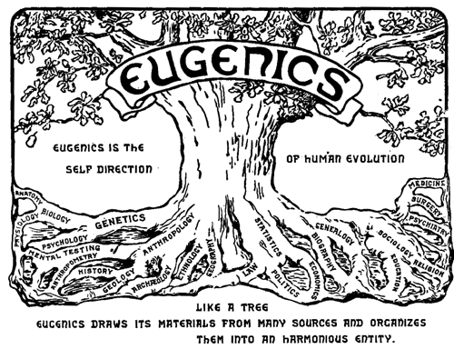

1883: 1883 sees the birth of eugenics – Francis Galton (cousin to Charles Darwin) coins the term, meaning “good genes”, to emphasize heredity as the cause of all human and behavioral differences. Eugenicists advocate selective breeding to engineer the “ideal” society. Their writings influence many aspects of American life, including immigration policy, marriage laws, involuntary sterilization, and schooling. This ideology will be even further developed in Nazi Germany. This “science” lays the groundwork for the school testing that we have today.
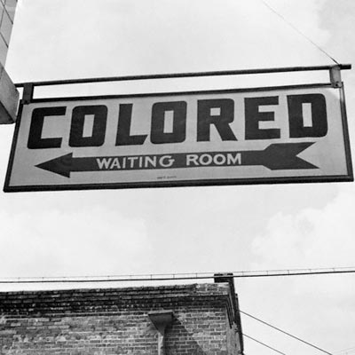

1890: As the white power structure in the South organizes against Reconstruction, they institute Jim Crow segregation, introducing a system of laws and practices designed to unite poor and wealthy whites, reinforcing racial solidarity and privilege while systematically targeting African Americans. Jim Crow laws and culture, reinforced through violence and intimidation, affect schooling, public transportation, jobs, housing, private life, and voting rights.

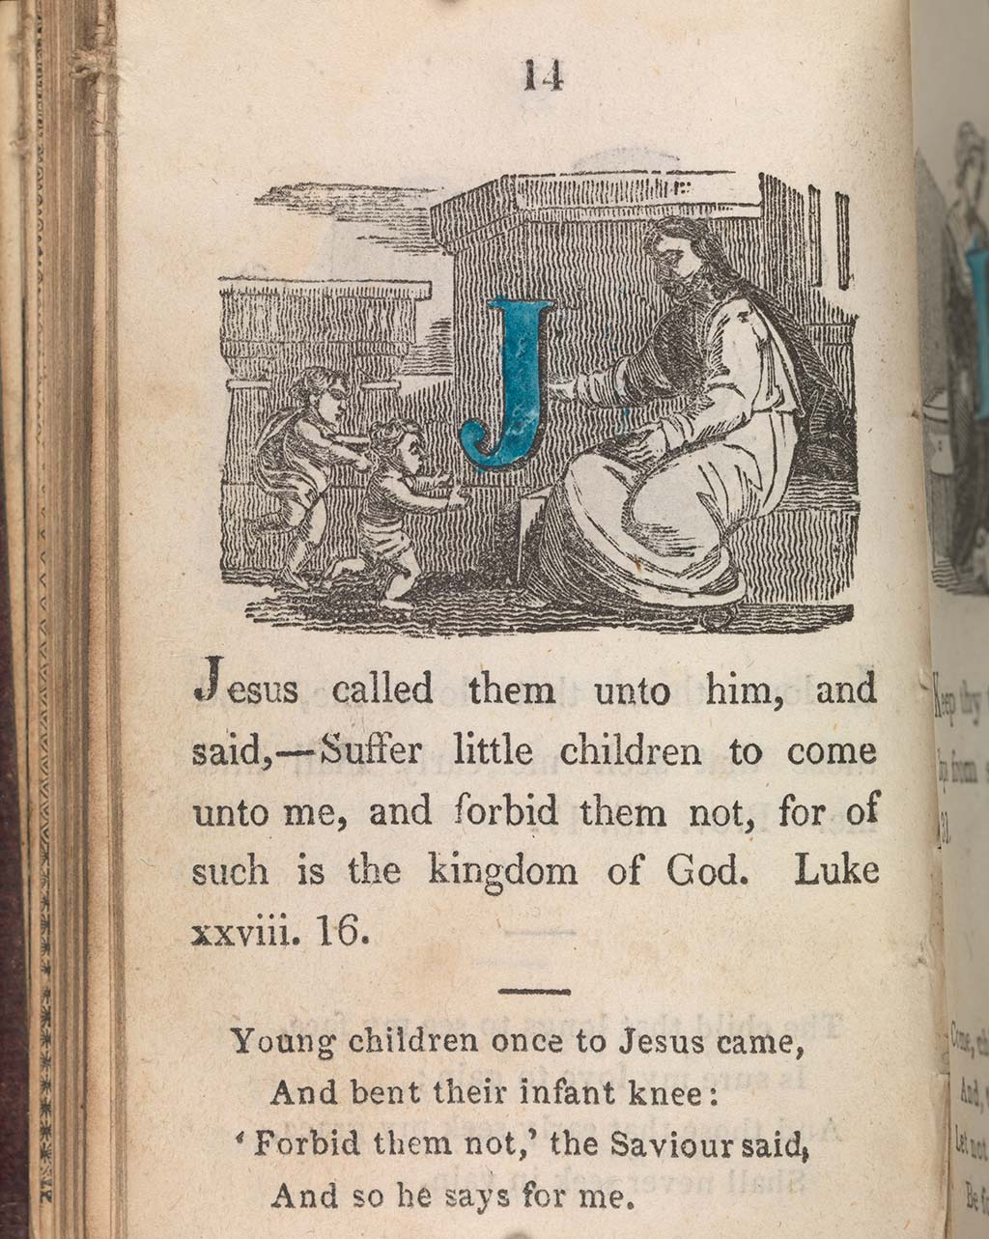

School textbooks serve as a major vehicle for transmitting white supremacy and racism. A 19th century primary grade textbook reads, for example: God is the creative process. He first made the black man, realized He had done badly, and then created successively lighter races, improving as He went along. To the white man He gave a box of books and papers, to the black man a box of tools so that he could “work for the white and red man, which he continued to do.”

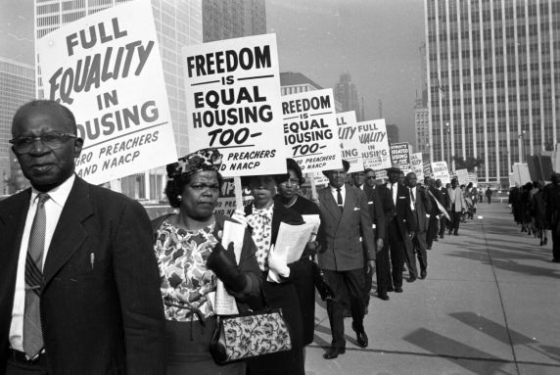

1909: The National Association for the Advancement of Colored People was founded by a collective of black and white abolitionist leaders and activists in direct response to acts of violence against black people, specifically lynching. The organization places a strong emphasis on local organizing, and has hundreds of branches all over the country fighting for the equality of minority groups and against racial discrimination.

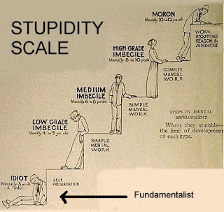

1910: Eugenics works its way into public education. The “science” plays a role in shaping teacher training, curriculum it also provides a space for IQ tests to track students into separate and unequal education courses.

1918: The American Federation of Teachers (AFT) is one of the first trade unions to allow African Americans and other people of color to become full members of the union. In 1918, the AFT calls for equal pay for African American teachers, the election of African Americans to local school boards and compulsory school attendance for African American children. In 1919, the AFT demands equal educational opportunities for African American children, and in 1928 calls for the social, political, economic, and cultural contributions of African Americans to be taught in the public schools.
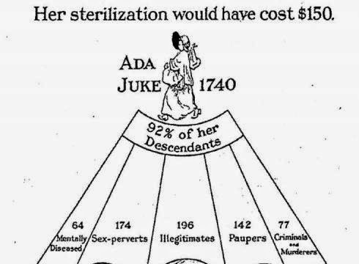

1913-1916: Henry Goddard took the IQ test to Ellis Island and ‘determined’ that 85% of Jews, 80% of Hungarians, 79% of Italians and 87% of Russians were feeble minded. Lewis Terman uses ‘science’ to prove that black and brown people and poor whites are feebleminded. All the individuals used to create his ‘norm’ in the study were native-born protestant American of northern European descent. This “science” is used to argue for the need for birth control and forced sterilization of black, brown and poor white women.
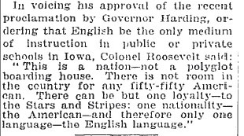

1918: Texas passes legislation making it a criminal offense to use any language but English in schools or when conducting school business. As a result, a survey of one Texas county in 1921 finds only 31% of Mexican school age children are in school at all. Mexican children who do attend school face segregation and an education designed, like that designed for the children of indigenous peoples, to rob them of their native language and culture. Similar laws follow across the United States.

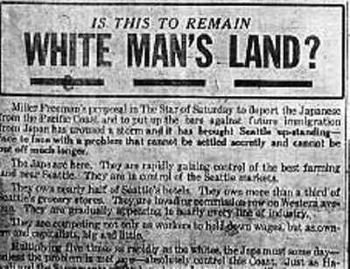

1922: The Thind case: many immigrants petition the courts to be legally designated white in order to gain citizenship under the 1790 Naturalization Act. The Supreme Court rules that Japanese are not legally white because science classifies them as Mongoloid rather than Caucasian. A year later, the court contradicts itself, saying that Asian Indians are not legally white, even though science classifies them as Caucasian, saying that whiteness should be based on “the common understanding of the white man”.

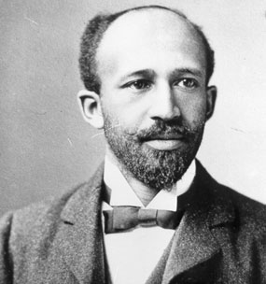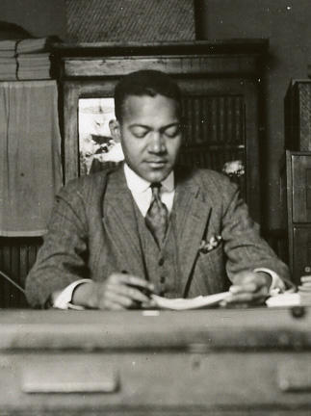

1922: Prominent Black scholars WEB DuBois, Horace Mann Bond and Howard Long challenge the assumptions of eugenics and its test. Educator John Dewey warned against any test “which under the title of science” reduces “the individual to a numerical class; judges him with reference to capacity to fit into a limited number of vocations ranked according to present business standards; assigns him to a predestined niche and thereby does whatever education can do to perpetuate the present order.”

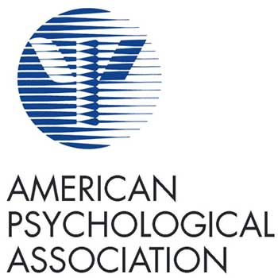

1923: Princeton professor and President of the American Psychological Association Carl Brigham researches and concludes that American intelligence was declining because of the presence of the Negro and says there must be ‘public action’ to prevent it.

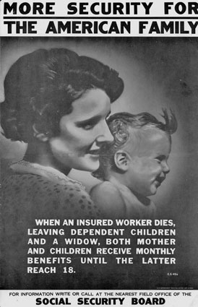

In the 1940s, Congress passes several laws to protect and support mostly American white workers and exclude others. The Social Security Act, which provides benefits to retirees, excludes agricultural workers and domestic workers (mostly African American, Mexican American, and Asian American). The Wagner Act guarantees the basic rights of private sector employees to organize into trade unions, collectively bargain for better terms and conditions, and take collective action, but allows unions to discriminate based on race. The G.I. Bill subsidizes employment, suburban home loans, and college education for veterans returning from World War II but refuses to challenge the discrimination embedded in the practices of employers, bank lenders, and college institutions; as a result, almost all of the benefits of the bill go to white veterans and their families.
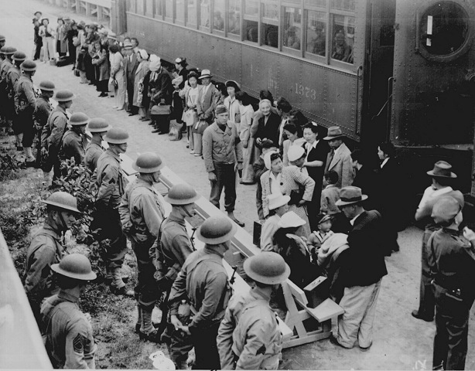

1942: President Roosevelt signs an Executive Order requiring Japanese Americans living within 20 miles of the Pacific Coast to relocate to ten internment camps. Over 112,000 Japanese Americans, including thousands of children, are forcibly removed from their homes and placed in military internment camps during World War II, their homes and property seized and sold to white Americans at reduced costs.

1944: In response to the growing threat of termination and assimilation policies in the United States, the National Congress of American Indians was established. The NCAI’s mission is to protect the treaty and sovereign rights of American Indians and Alaskan Natives, secure traditional laws and cultures of their descendants, and to overall improve the quality of life for Native communities. The initiatives of NCAI advocate for the visibility and protection of Native lives within the United States.

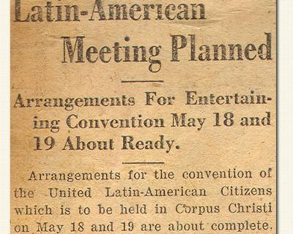

1945: California Council of the League of United Latin American Citizens (LULAC) successfully sued to integrate the Orange County School System, which had been segregated on the grounds that Mexican children were “more poorly clothed and mentally inferior to white children.” Additionally, in 1954, LULAC brought another landmark case, Hernandez vs. the State of Texas, to protest the fact that a Mexican American had never once been called to jury duty in the state of Texas. The Supreme Court ruled this exclusion unconstitutional.

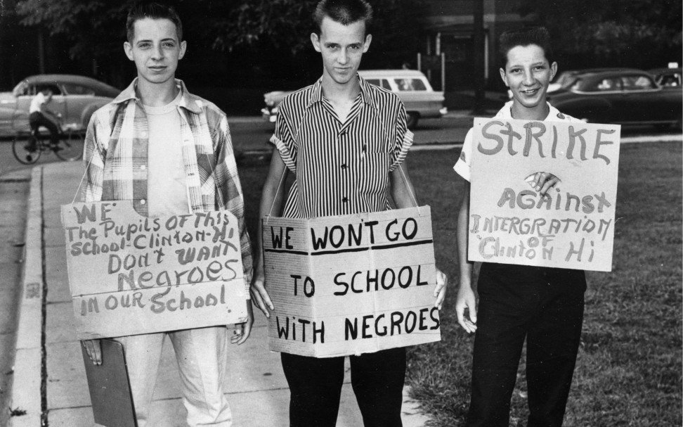

1954: The Supreme Court rules in Brown v. Board of Education that separate means unequal and mandates desegregation of public schools. In Southern schools, thousands of black teachers and principals are fired as School Boards claim that white parents will not allow their children to be taught by black teachers. As a result, thousands of white men and women get jobs in the newly integrated schools, while black teachers and administrators, often the backbone of the African American community, are shut out.
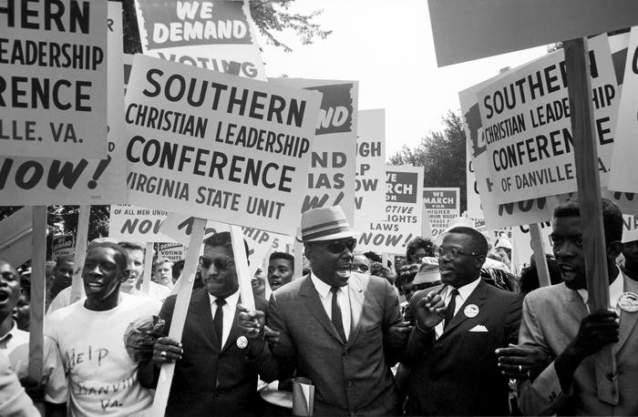

1957: In response to the successful strategies of the Montgomery, Alabama bus boycotts, the Southern Christian Leadership Conference (SCLC) was formed by 60 black ministers and civil rights leaders. The SCLC helped organize the sit-in movement and the Freedom Rides, along with the Student Non-Violent Coordinating Committee (SNCC), an activist organization formed by black college students. The efforts of both groups to protest racist violence and advocate for voter registration and the desegregation of public services and accommodation led to President John F. Kennedy’s call for a national Civil Rights Act.
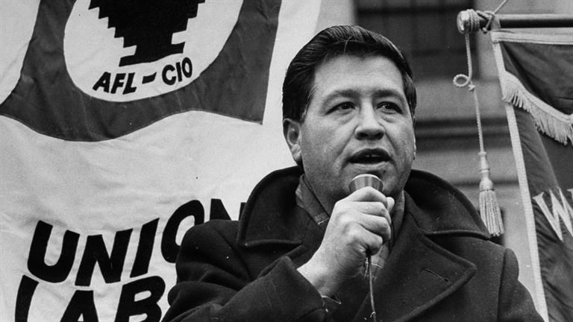

1962: The National Farm Workers Association was a labor union formed during the Civil Rights Movement in response to the century-long exploitation of California’s farmworkers. The NFWA, led by Cesar Chavez, successfully organized farmworkers to protest poor working conditions and low wages, as well as boycott certain agricultural products, including grapes. At its height the union successfully recruited over 50,000 farmworkers, and continued to organize well into the 1970s.

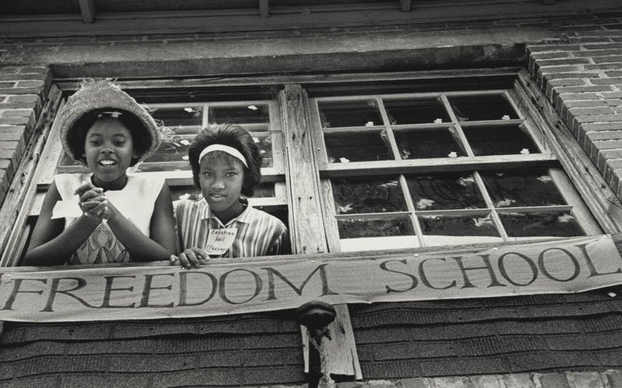

Richard Parrish leads a successful campaign to expel segregated locals from the American Federation of Teachers (AFT), a move that costs the union in members and dues but allows it, as he states, “to show by our example that desegregation is not only morally right but that it would work.” When local officials respond to federal desegregation orders by closing public schools and shifting resources to segregated private academies, he recruits union members to run “freedom schools” for black students in Virginia, Mississippi and other states.

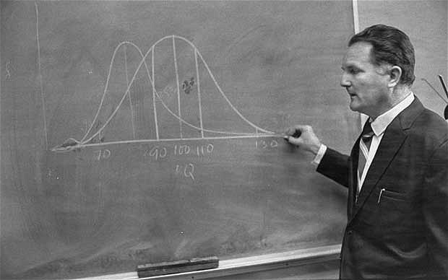

1969: The educational psychologist Arthur Jensen published a long article suggesting that poor educational outcomes are due to genetic differences between groups. A similar debate followed the 1994 publication of The Bell Curve by Richard Herrnstein and Charles Murray, which suggested that there are racial differences in intelligence. Their book prompted heated controversy and many articles and books in opposition and in support.
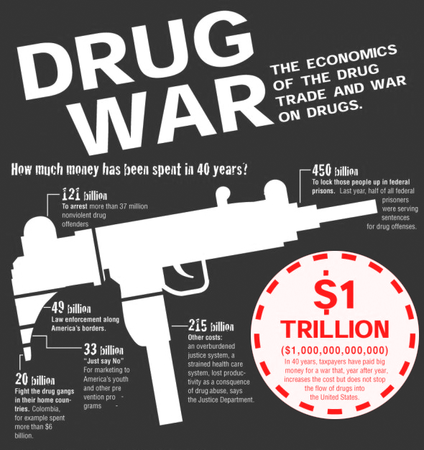

1980s: Building on President Nixon’s “War on Drugs,” the Reagan Administration increases the number of people behind bars for nonviolent drug offenses. In the late 80s, Congress passes harsh penalties that rapidly increase the prison population. The U.S. currently spends more than $51 billion on the war on drugs and we incarcerate 1 in every 99 adults, the highest incarceration rate in the world. Over two thirds of those imprisoned are black or Latino although these populations use and sell drugs at the same rate as whites. In recent years, as the heroin epidemic has shifted to affect mostly white populations, the “war on drugs” has scaled down and there is a much greater emphasis on rehabilitation and supportive services.
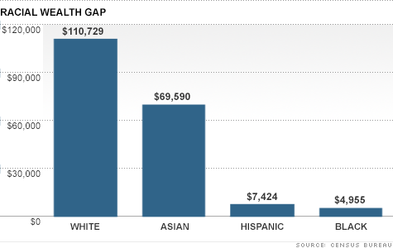
(2012)

1994: The average white family has eight times the wealth of the average family of color. Even at the same income level, whites have, on average, two to three times more wealth. 71% of whites own their own home, compared to 44% of African Americans. Black and Latino mortgage applicants are 60% more likely than whites to be turned down for loans, even if they have the same for employment, financial, and neighborhood characteristics.

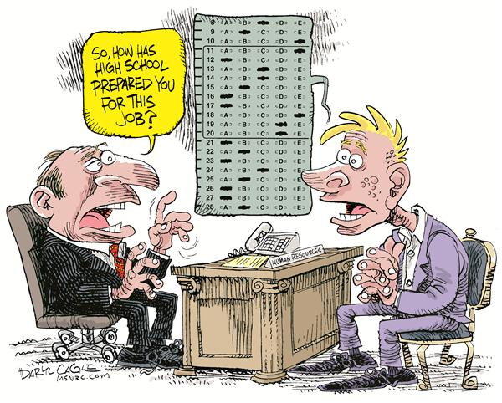

2001: New national education legislation, No Child Left Behind (NCLB), is introduced based off of George W. Bush’s “Texas Miracle”. The Texas Miracle appeared to show significant reductions in dropout rates throughout Bush’s term, when in reality school officials were not properly classifying students who should have been recorded as drop outs. No Child Left Behind (NCLB) made testing mandatory for all public schools, every year, with severe consequences if test scores didn’t rise.

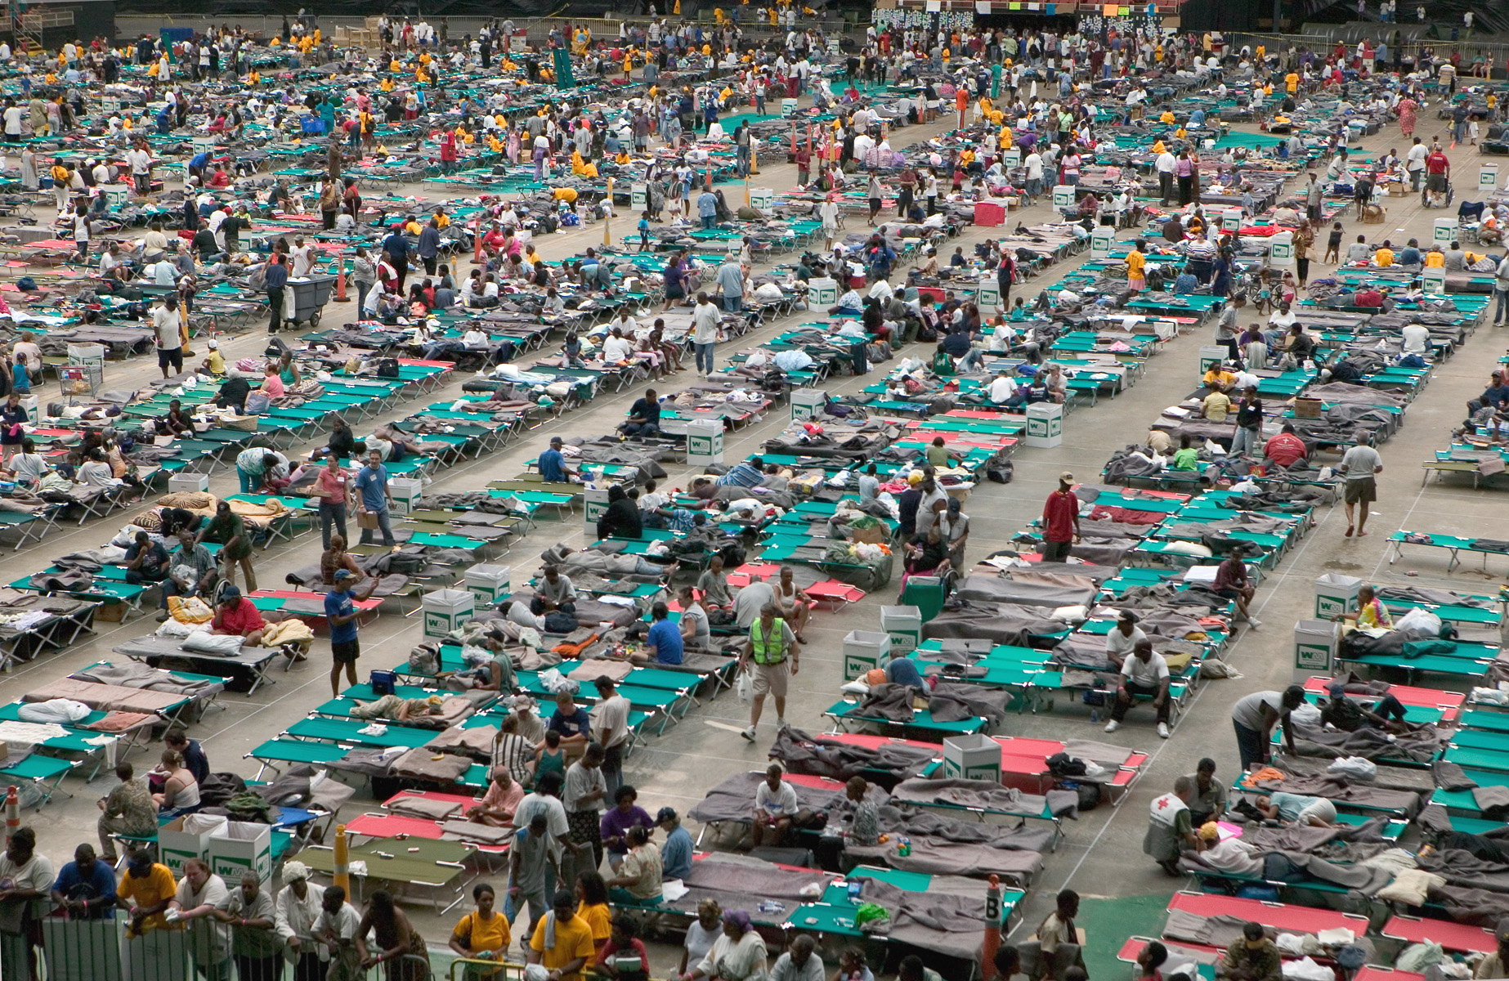

2006: Hurricane Katrina hits New Orleans. The neighborhoods with the highest proportion of African Americans sustain the worst damage. Thousands of African American residents who try to leave by crossing the Gretna Bridge to higher ground are forced back into the flood by gun toting white vigilantes. The media describes white people as “flood victims looking for food” and black people as “looters.” Residents have to go through criminal record checks before Red Cross Centers will admit them. Curfew is only enforced against black people. Ten years later, the demographics of the city are changing dramatically with white people settling into areas that were historically black neighborhoods, and the entire public school district has been converted into charter schools.
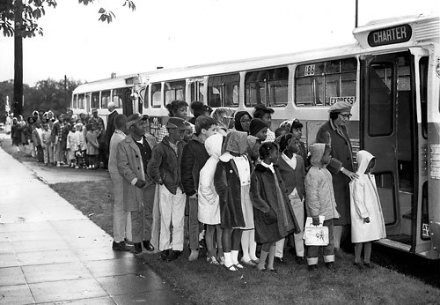

2007: The Supreme Court finds involuntary school integration (i.e busing) plans unconstitutional, paving the way for contemporary school segregation to escalate. A study by Harvard's Civil Rights Project finds that schools were more segregated in 2000 than in 1970 when busing for desegregation began.

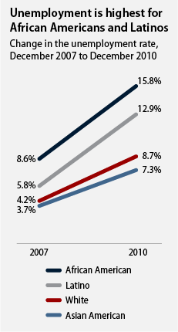

2008: A Recession hits and yet doesn’t hit everyone equally. As a result of subprime mortgage lending crisis, the total loss of wealth for people of color was between $164 and $213 billion over eight years, perhaps the greatest loss of wealth for people of color in modern U.S. history.

Black youth are disproportionately suspended, expelled, and arrested by harsh school policies that criminalize student behavior. In standard academic classrooms, black youth are more than three and a half times more likely to be suspended than white counterparts. This is especially true in special education classrooms where the suspension rate for high school age black boys is 3651% compared to white boys at 6%.

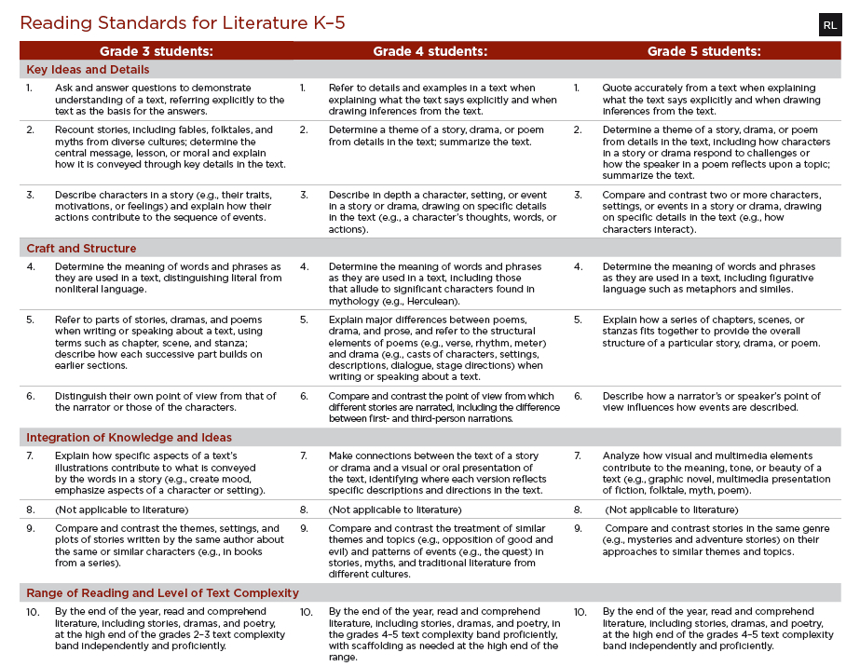

2010: Common Core Standards were created by a consortium of states and adopted by many states nationally. Since then, a backlash against the standards has driven many states to reject them.
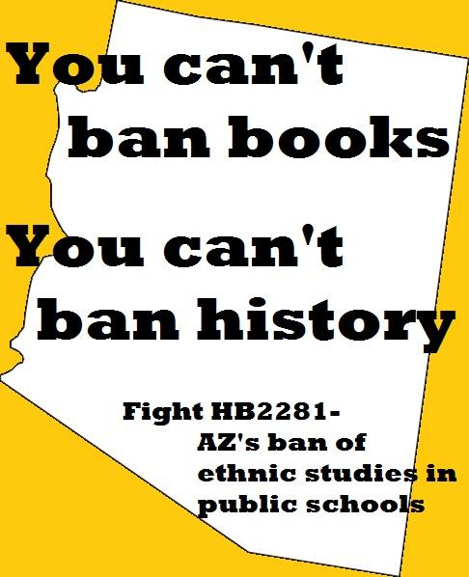

2010: Arizona House Bill 2281 was passed in 2010 in an effort to ban the extremely successful Mexican American Studies program in the Tucson Unified School District. In response, student and teacher activists and lawyers fought back, appearing at governing board meetings to protest the ban and organizing a group of “Librotraficantes”, book smugglers, to bring banned books into the Tucson Unified School District. National media attention of the case in Arizona has inspired teachers and school districts in states such as California and Texas to implement culturally relevant curriculum practices, including mandatory ethnic studies courses.
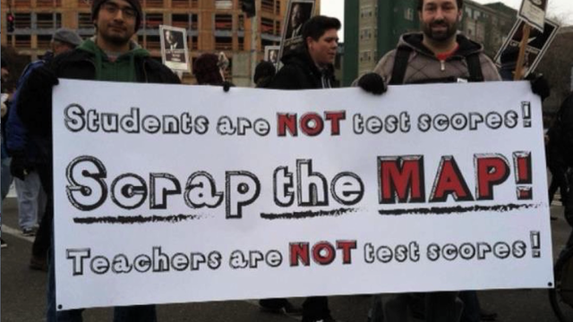

2013: Teachers at Garfield High School in Seattle refuse to administer the district’s standardized test, called the Measures of Academic Progress (MAP), to their students. The teachers argue that student learning should be evaluated based on portfolios of student work, rather than high-stakes testing. After months of protests from teachers, students, and parents, the Seattle Public School District announced that the MAP testing would be optional for high schools.

2014: In response to increased use of standardized tests, parents across the country organized a national “opt out” movement, refusing to allow their children to take the standardized tests. Due to protests, boycotts and other actions led by organizations such as Fair Test and United Opt Out, several states repealed or delayed graduation test requirements, while others have reduced the number of required exams. In response, the Obama Administration asserted that the push for high-stakes testing had “gone too far” and encouraged schools to take a step back from testing. In New York State, 200,000 third through eighth graders, 20% of NY State students, opted out of testing in 2015. At NYC’s Riverdale Avenue Community School (PS 446), Academy of Arts and Letters, and Brooklyn New School (PS 146), more than 70% of parents refused for their children to take the tests.
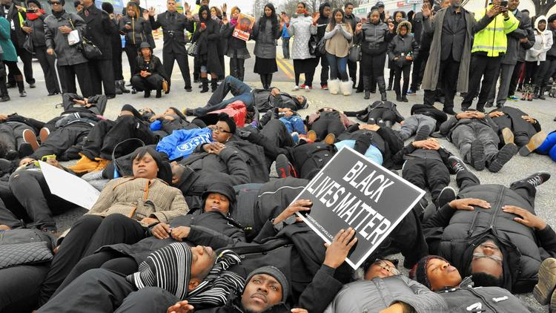

2015: Public outcry over racialized police violence swells and the Black Lives Matter movement and other allied movements calling for racial justice begin to take center stage.

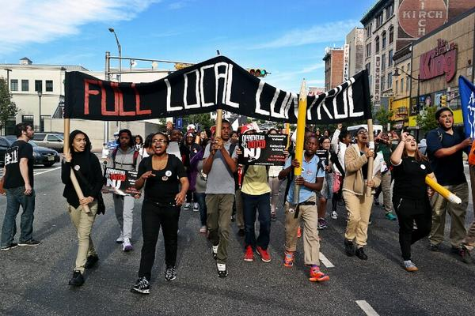

2015: Students from the Newark Students Union in Newark, New Jersey stage a walkout to protest district policies, specifically Superintendent Cami Anderson’s plans to close neighborhood schools and convert them into charters, and to demand community control of local schools. As a result of the protest and persistent criticism from parents and education leaders, Cami Anderson resigned as superintendent several months later.
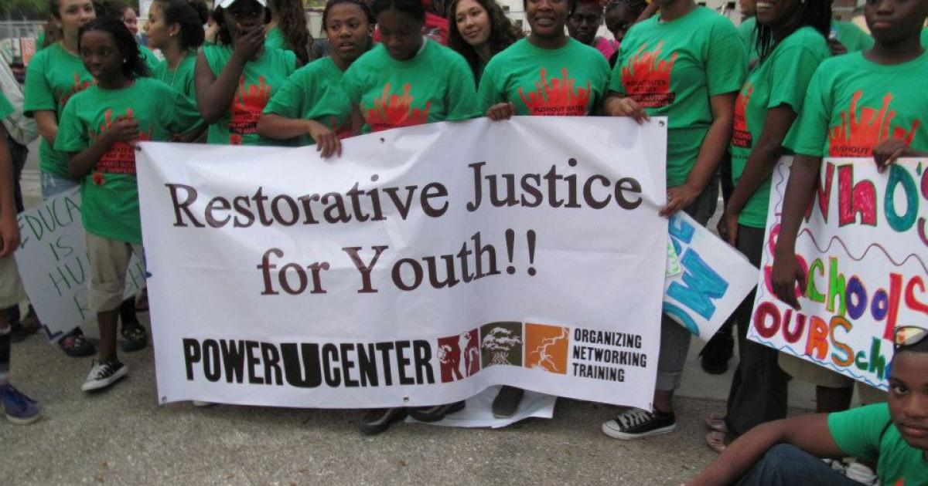

Harsh discipline policies that take place in public schools, including suspensions for low-level infractions, zero tolerance policies, school-based arrests, referrals to juvenile detention, among others, contribute to the school-to-prison pipeline crisis. The Dignity in Schools campaign, a national coalition of educational justice groups, along with local organizing efforts such as the National Opportunity to Learn Campaign and the Urban Youth Collaborative, work to fight against these unjust policies that disproportionately impact students of color, students with special needs, and LGBT students.
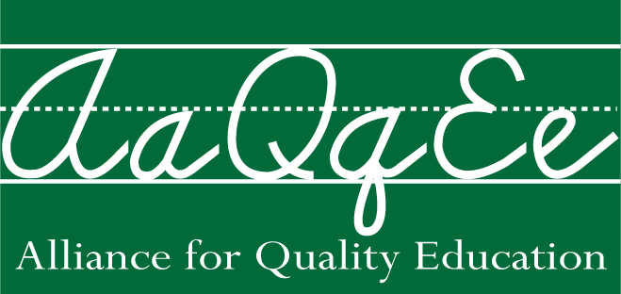

Advocacy groups such as the Alliance for Quality Education in New York support policies that promote fair and equal funding for public schools. In an effort to increase access to resources and services to the most underserved schools, AQE advocates for shared fiscal responsibility to ensure that adequate funding is distributed to the schools that need it the most.

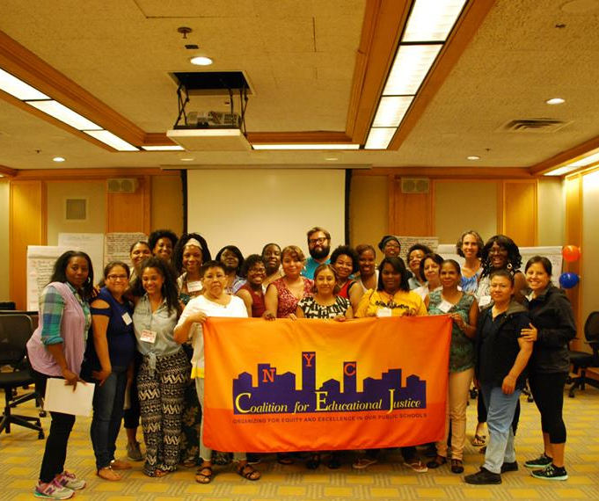

The Coalition for Educational Justice organizes parents to advocate and fight for high quality and well-rounded education in communities of color. CEJ works to find and uplift solutions to combat the inequities within our educational system.

