INTERNALIZED  Internalized racism: Internalized racism is when a group that is targeted by racism starts to believe the lies and stereotypes that the racist society holds about them.  Example: Perception that lighter skinned women are more beautiful than darker skinned women. | INSTITUTIONAL  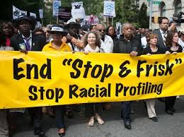  Institutional Racism:  Societal institutions such as education, health care, housing, employers or the court system carry out policies that discriminate against certain groups of people through the use of biased laws or practices.  Example: Jim Crow laws, segregated schools, Japanese internment, housing redlining, pay disparity, drug sentencing laws.
INTERPERSONAL  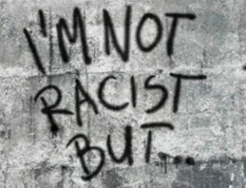  Interpersonal Racism: Interpersonal racism occurs between individuals, when people from the dominant racial group act out their racism on people from the oppressed racial group.  Examples: Stereotypes and prejudicial attitudes about the competency, honesty, intelligence, appearance, etc. of a racial or ethnic group. (Mexicans are lazy, Jews are cheap, Chinese are not trustworthy, Blacks are hypersexual.) | STRUCTURAL  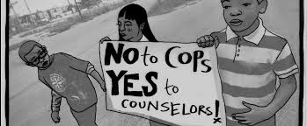  Structural racism: When racial bias intersects with more than one institution at the same time.  Example: The school to prison pipeline, where school policy intersects with policing practices. Discriminatory housing practices and school zoning keeps schools segregated based on race

Four Types of Racism

Glossary of Terms

Race as a construct: Race is not a biological fact. It is a “social construct”, meaning it was created by societies to serve the goals of those in power. There is no gene or cluster of genes common to all blacks or all whites. Ethnicity can overlap with race but is based on a shared cultural heritage.

Racism/racial discrimination: Prejudice, discrimination, or antagonism from members of the dominant racial group towards the oppressed racial group.

Racial justice: The active enforcement of policies, actions and attitudes that produce equitable power, access, opportunities and treatment for all.

White supremacy: The belief that white people are superior to those of all other races, especially the black race, and should therefore dominate society.

Transatlantic slave trade: The business or process of procuring, transporting, and selling slaves, especially black Africans to the Americas.

Abolitionism: The movement to end the African and Indian slave trade in Western Europe and the Americas and set the enslaved people free.

Feebleminded: An unintelligent person (synonyms: stupid, idiotic, simple)

Eugenics: The movement to improve and preserve “good” genetic traits and genes.

Indigenous: Originating or occurring naturally in a particular place: native. In the United States it mostly refers to Native-American (also called Indian) people.

Segregation: The enforced separation of different racial groups in a country, community, or establishment. In the USA, segregation was reinforced by “Jim Crow” laws.

Recession: A period of temporary economic decline.

Depression: A long and severe recession in an economy or market.

Reconstruction: The period after the Civil War when Southern states were controlled by the federal government and subject to laws supporting black economic and educational development.

Sterilization: A medical procedure that results in infertility.

Internment camps: A prison camp used to confine people perceived as wartime enemies.

Freedom Rides: A group of black and white Northerners who rode interstate buses into the South in the early 1960s in order to challenge racial segregation.

